Perpetual Motion- The holy grail of inventors   
- Abhinav Sarkar, BVCOE

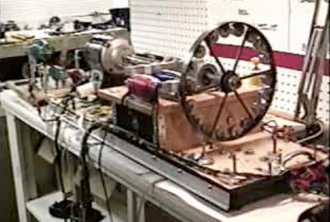

For centuries, the perpetual motion machine has been regarded as the holy grail of science. Many scientists and inventors have tried to make it, but none have succeeded. A perpetual motion machine is basically a device which, once set in motion, continues to produce energy without any external intervention. Simply put, it is a wheel which continues to rotate till the end of time. Seems pretty far-fetched, doesn’t it?

The whole concept of perpetual motion machine is flawed. It is basically a device which produces infinite energy, but according to the First Law of Thermodynamics, “Energy can neither be created nor be destroyed.”

Another kind of perpetual motion machine is usually defined as one that completely eliminates friction and other dissipative forces, to maintain motion due to inertia of mass. But such a device is impossible to make, as friction cannot be eliminated totally in any system.

Early designs of perpetual motion machine were made by Indian mathematician Bhaskara-II, during the 12th century. Bhaskara described an overbalanced wheel that he claimed would run forever. Leonardo Da Vinci made numerous drawings of devices that he believed would make free energy. Another 16th century Italian scholar proposed a self-blowing windmill. Robert Boyle devised a perpetual motion cup which he claimed could sustain fluid flow forever. More perpetual motion devices followed in 17th century. None of these worked.

In 1775, The Royal Academy of Sciences in Paris, having had enough, made a statement that “The Academy will no longer accept or deal with proposals concerning perpetual motion.” Later, even the United States Patent and Trademark Office made an official policy of refusing applications regarding perpetual motion machine without a working model.

Regardless of this, the madness behind perpetual motion machine still continues and every year the patent offices around the world receive many applications regarding perpetual motion machines, most of them fraudulent or non-working.

Even though I am not the type to discourage new inventors, but still I would like them to steer clear from perpetual motion because it’s long been established that it’s a wild goose chase. As appropriately put by Leonardo Da Vinci,

“Oh ye seekers after perpetual motion, how many vain chimeras have you pursued? Go and take your place with the alchemists!”

